5G Live Trials in MTNL/ BSNL Network by VoICE Stakeholders
(Lekha Wireless, VVDN & Galore) in Consortium Mode
by
RAKESH KUMAR BHATNAGAR, DIRECTOR GENERAL along with Consortium teams

Live 5 G trails are being done in MTNL’s Network using BSNL’s 700 MHz Spectrum. In general coverage is available within 2 KMs range of the tower. In all cases, BSNL has provided its Spectrum along with Towers, power supply, infrastructure support for housing of equipment. Other 5G equipment and add on equipment is brought in by VoICE consortium partners in each live 5G trial on their own with no financial support from BSNL or DoT or any other organisation.
Voice, Data and Video calls are supported in the trial runs.
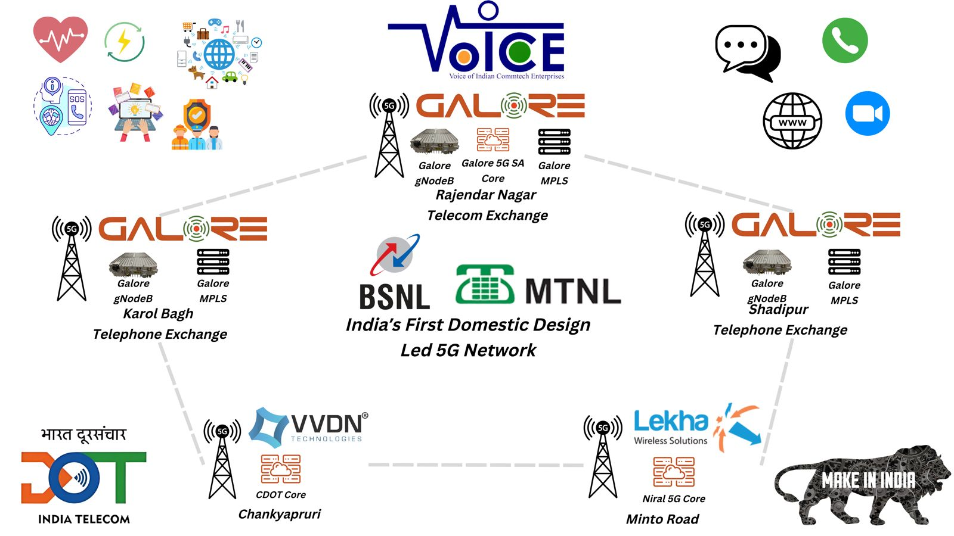

S. No. | Main Player | Support Partners | Location
1 | VVDN | CDoT, BSNL | Chanakyapuri, Delhi
2 | Lekha Wireless | Niral Networks, BSNL | Minto Road
3 | Galore Networks | Coral, BSNL | Karal Bagh, Rajendra Nagar, Shadipur in Delhi

TCS has also taken up a similar trial runs in Delhi. In addition, other VoICE teams led by CDoT, Signaltron, WiSiG, BigCat Wireless, Wireless 4 Space (IIT Delhi), ITI, ECIL, Tidal Wave and some more are ready to go for similar 5G trial runs by Deepawali time in multiple locations across the country provided any positive signals come out of the first set of 5G live deployments. With most of the stakeholders implementing in Consortium mode and most of them are having limited turnover, they cannot afford free trial runs at multiple sites.
MTNL, India’s large, government-owned mobile network services provider in Delhi and Mumbai, has launched 5G trial runs in Delhi. Success of 5G trial runs will transform MTNL’s current legacy 2G and 3G mobile network service, providing high throughput, low latency, low jitter, and full high-speed mobility.
As part of a public-private partnership, BSNL (MTNL) has invited Indian companies to deploy and showcase their 5G solutions in their live operational network. In addition to delighting subscribers with this transformational change to their mobile services, BSNL (MTNL) will also be supporting Indian-owned 5G mobile network equipment manufacturers, with this initiative. Indian OEMs will be able to deploy and meet the challenges of real-life mobile network deployment, at scale. This will enable them to grow and compete at a global level, and gain instant nationwide and global visibility. The initiative will also make India independent in this critical strategic area.
VoICE team has ensured that for 5G Intelligent Villages more than 100 proposals are submitted to the Government under TTDF support. Soon Smart Healthcare. Smart Education, Smart Irrigation, Smart Street lighting, Smart Water management, green solutions, Smart governance are also works in progress and by Deepavali time many villages will have above implementation again in Consortium mode from VoICE team members. VoICE DoT Intelligent Village Presentations organised at Delhi on 10 July 2024 captures many implementable solution presentations.
https://voiceofindiancomm.com/assets/pdf/A-Workshop-on-Designing-5G-Intelligent-Villages1.pdf
Success of the Consortium model can do wonders as replication of the Model of Intelligent and Smart Villages across the country can lead a fast march to double digit GDP growth in very near future on the strength of Rural Economy soon. In all proposals, support has come from BSNL as Spectrum support partner.
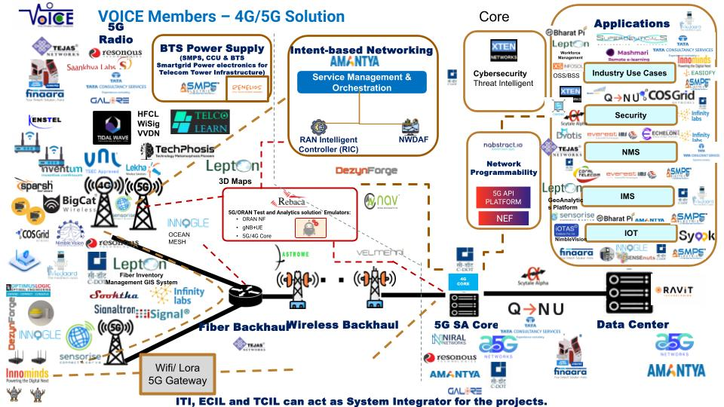

Similarly VoICE team in partnership with BSNL is going in for 5G Private Enterprise Network solutions across multiple PSUs and sectors and before the end of the year, many positive announcements, orders and MoUs are quite likely. 5G CNPN PROJECTS as released during Bharat Telecom event in January 2024
https://voiceofindiancomm.com/assets/pdf/VoICE-CNPN-5G-Projects.pdf
and series of Private Enterprise Solution presentations on possible collaboration between BSNL and VoICE members is covered under attached link
https://voiceofindiancomm.com/assets/pdf/VoICE-CNPN-Presentations-and-Collaboration-BSNL1.pdf
Disaster Management, Railways modernisation, Network I a Box, vehicle mounted 5G communication systems can be supported by VoICE players in Consortium mode.
Domestic design led industry in Consortium mode are capable of challenging established global players provided support from Government and BSNL continues.
https://docs.google.com/spreadsheets/d/1GWym_j54K_xs4Hnr3Mbb8gIXJ6ODzasbxK_L0J-UQ90/edit?usp=sharing
Present CMD BSNL, Shri Robert Ravi needs to be complimented for supporting the innovative capabilities of domestic design led players from VoICE.
There is a small difference between a success story and failure. We at VoICE are quite sure that under the lead of dynamic Minister of Communications and supervision of hon’ble Prime Minister, all support required for success should be coming.
VoICE members are ready to be support partners of BSNL or even other licensed service providers to implement 4G and 5G Networks across the country including 5G CNPN Networks and Intelligent Village Networks across the country. VoICE teams can support the Technology march in coming weeks aggressively.
5G provisioning by Home Grown players with enough level of competition Is possible and vision of Hon’ble Prime Minister for Indian Global lead starting with 5G and then going forward to 6G is also sure to materialise but there is a rider of support from the Government system.
RESPONSES BY 3 Stakeholders implementing 5G Trials in Delhi

Responses to some of the queries on 5G live trials as responded by three implementing teams are given below.

- Locations of Live 5G Trials and Spectrum used
Lekha Wireless
Lekha Wireless has deployed at the MTNL’s Minto Road location, with support from Niral Network for its core and others for support equipment by BSNL (Towers, Power Supply, Infrastructure). Band 28 / 700MHz spectrum is used.
VVDN
VVDN has deployed at the MTNL Chanakyapuri location, with participation from VVDN and BSNL with support of CDOT, WiSiG.
GALORE
Galore is deploying three sites at MTNL’s locations in Rajendra Nagar, Karol Bagh and Shadipur.
Spectrum used is Band 28.
Galore can offer its product even in other bands like B1/ B35/ B20/ B28/ B78.
Galore has also partnered with its IMS partner Coral Telecom to connect 5G network to legacy 3G network thereby ensuring seamless connectivity for BSNL customers.

2. 5G architecture used and provider of the core network
⁠Lekha Wireless:
Deployment is ORAN 5G Network with stand-alone. The Core network is coming from Indian companies like Niral and others.
VVDN
The architecture is based on an Open RAN solution, with end-to-end services provided by VVDN Technologies.

3. Possibilities of participating homegrown startups getting commercial 5G deals from BSNL
Lekha Wireless
Yes of course. We already have the experience of building and deploying carrier grade 4G Network in parts of BSNL’s Karnataka Circle using funding from USOF.
VVDN
Yes, we are fully capable of supporting 100% Make in India Design and Manufacturing solution for BSNL for commercial deployments, Private Enterprise Networks, and even Intelligent networks. We have 7 manufacturing facilities at Manesar and more in other southern states.
GALORE
Galore is commercially ready for deployment with BSNL, Private 5G Network in partnership with BSNL and other Service Providers to meet the requirements of PSUs in Mining, Refinery, Steel Plants and multiple industrial 5G use cases. Homegrown companies like Galore are fully equipped commercially and technically to deploy commercial network. In short, answer is a bold YES.

4. Broader trial run objective and usefulness to BSNL, homegrown companies, and consumers
Lekha Wireless
Broader objective of 5G live trials is to have first-hand experience prior to launch of full-fledged commercial 5G deployment for MTNL and BSNL customers in Metro cities. This will provide multiple competitive deployment options to BSNL through domestic technology and they can play the role of support partners and the model can even work not only in in India but even in and global markets.
⁠VVDN
The goal is to develop a fully indigenous 5G solution that can be deployed locally and globally, positioning India as a leader in the telecommunications sector.
GALORE
The objective is to reduce the import bills, dependence on MNCs and provide cost effective Total Cost of Ownership for operator (BSNL) and affordable 5G connectivity for BSNL customers. Galore’s range of 5G products offers flexibility in deploying disaggregated RAN which can bring the Total Cost of Ownership down for BSNL and other operators worldwide subsequently.

5. Challenges needed to be addressed
Lekha Wireless
Domestic companies must continue the investment on R&D along with investment towards commercialization. Support is required not only from government for R&D funding but operators also in offering encouraging commercial models to domestic 5G partners which will help domestic companies to gradually scale up the 5G roll out.
VVDN
We need to move forward with more site deployments commercially and run the entire system with live traffic to observe. We have the complete technical teams for supporting commercial deployments.
Orders also need to come from Service providers like BSNL.

Galore
Galore and its Indigenous consortium partners need more diversity in its supply chain to bring the down the cost of goods sold. We are happy that Government of India is already working towards it. Also, if Indigenous companies like Galore gets reserve quota in Public & Private telecom gear procurement, it will act as a catalyst to the growth of home-grown companies.

Some Installation pictures from the sites are shared.

PICTURES FROM VVDN DEPLOYMENT AT CHANKYAPRI

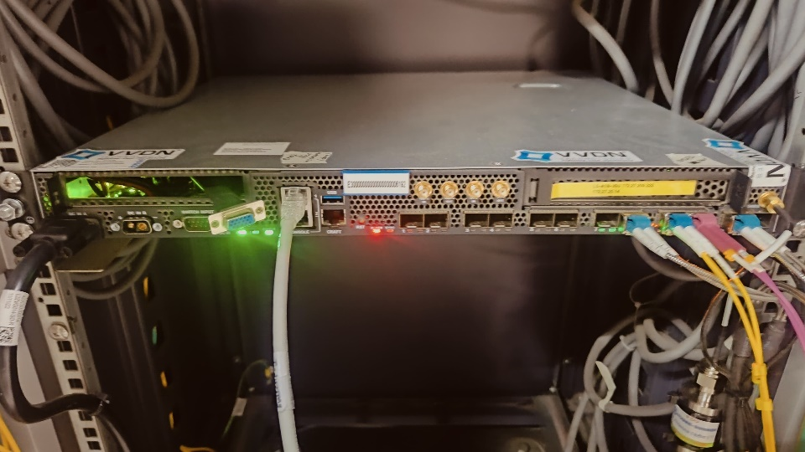
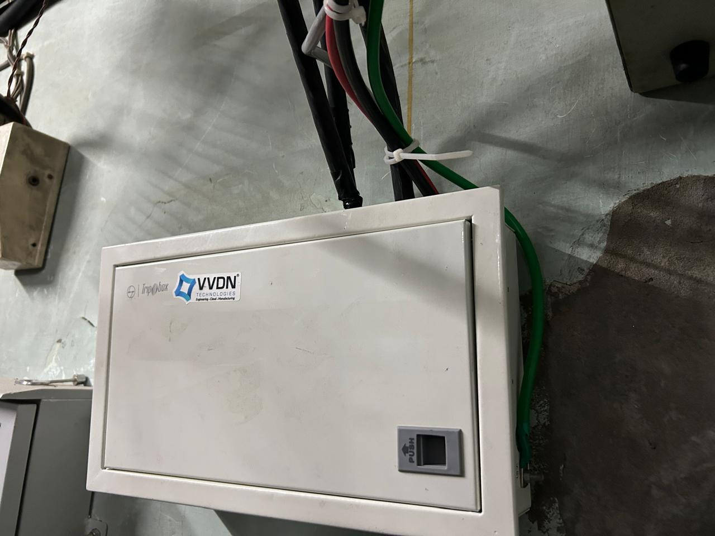
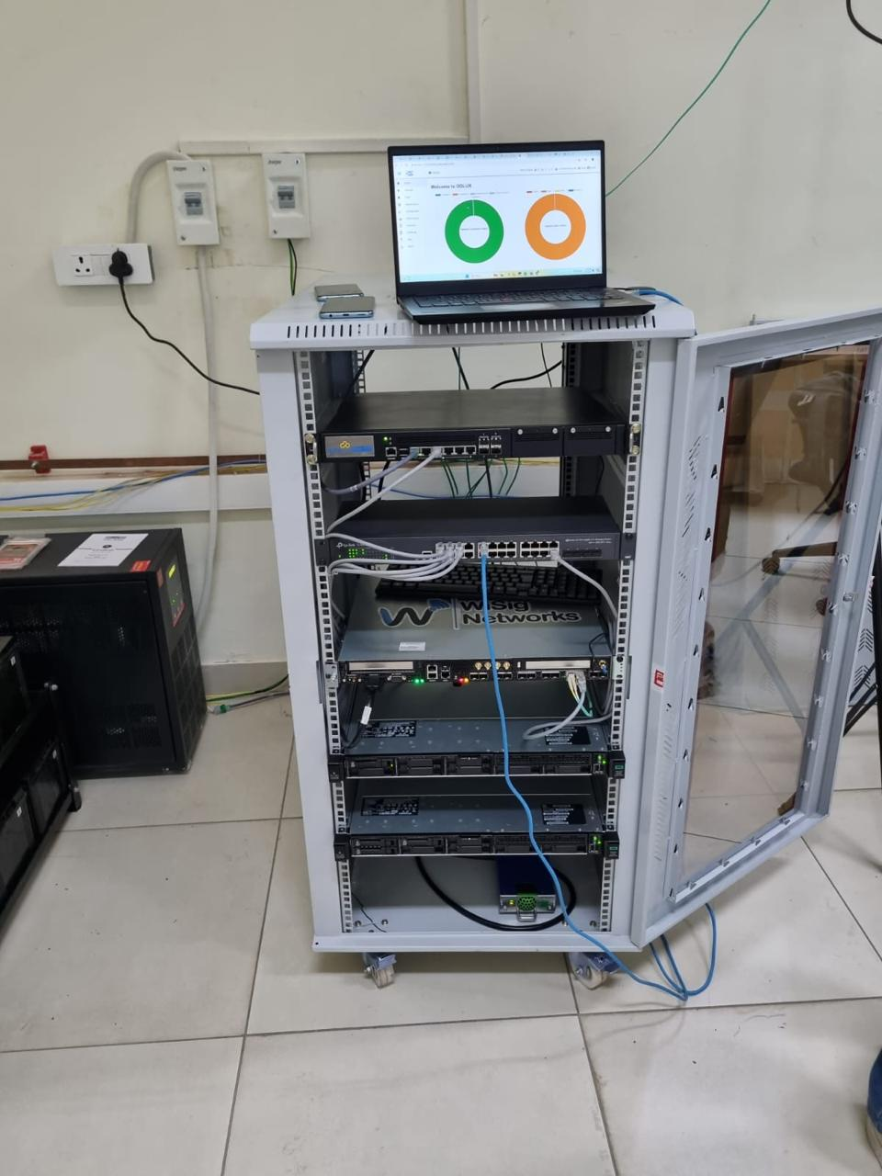
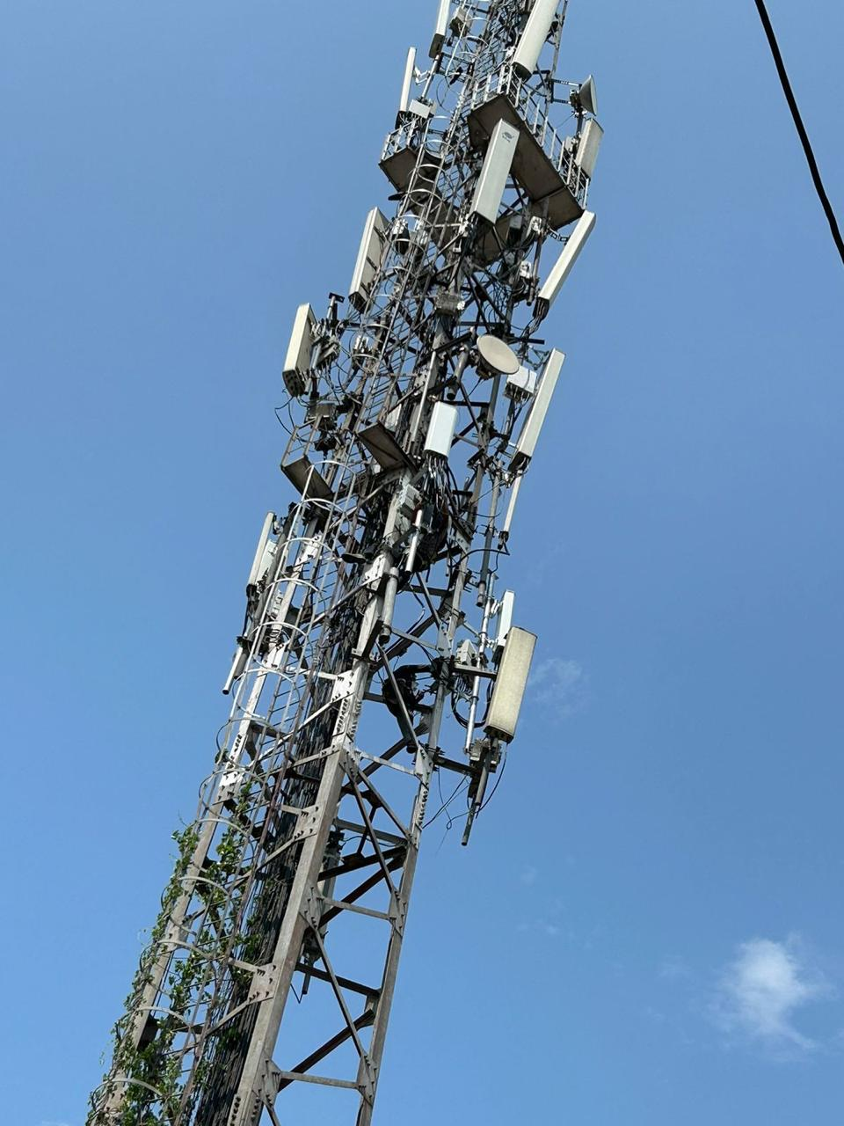
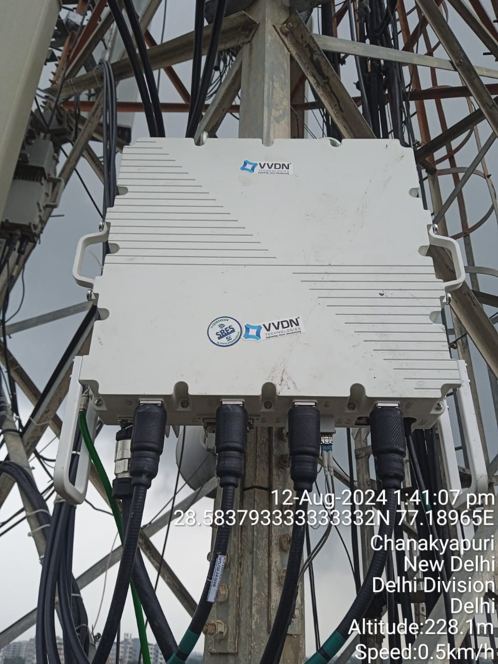

PICTURES FROM LEKHA’s 5G DEPLOYMENT AT MINTO ROAD

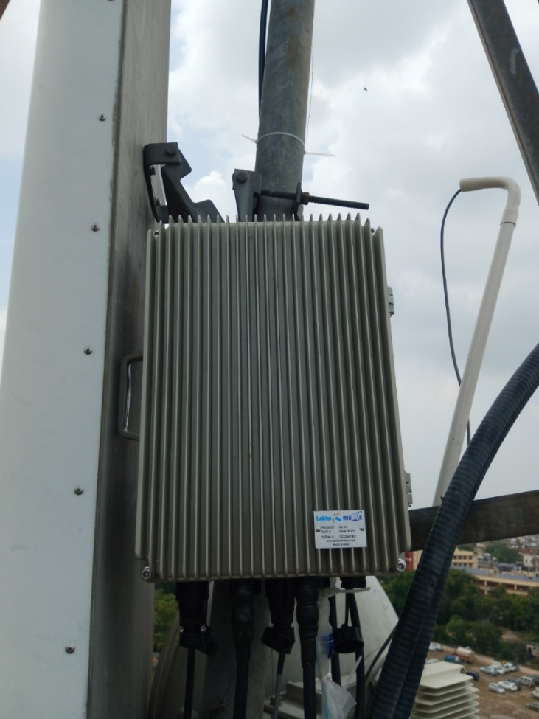
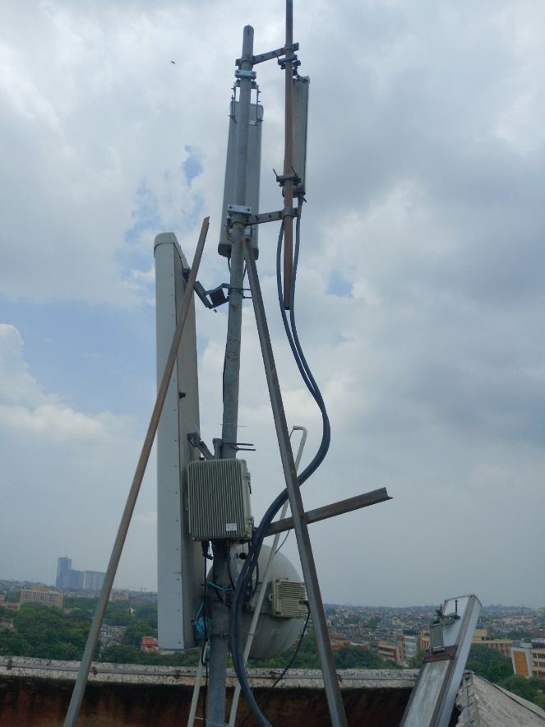
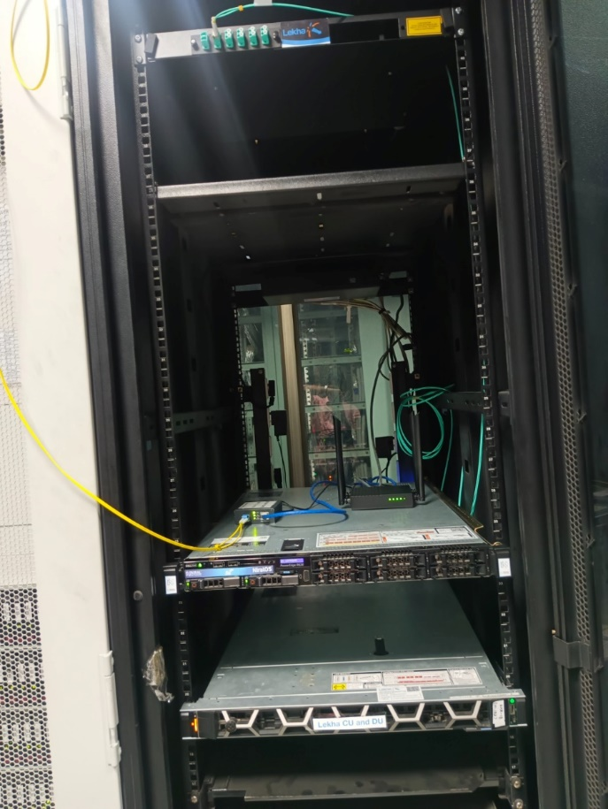
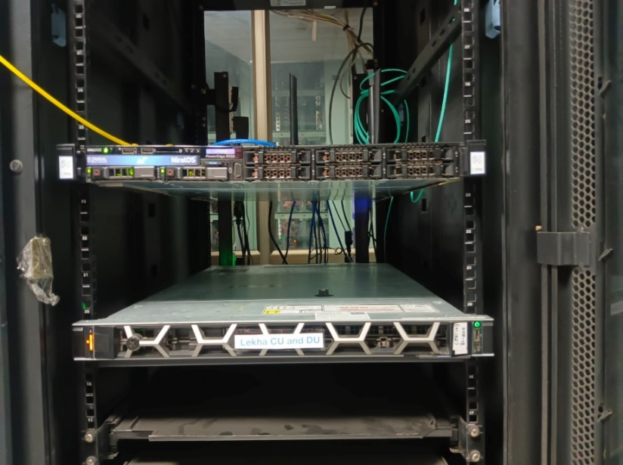

PICTURE FROM GALORE at KAROL BAGH

